**Monitoring Task**

**STEP 1: -** Install EC2 VM from AWS

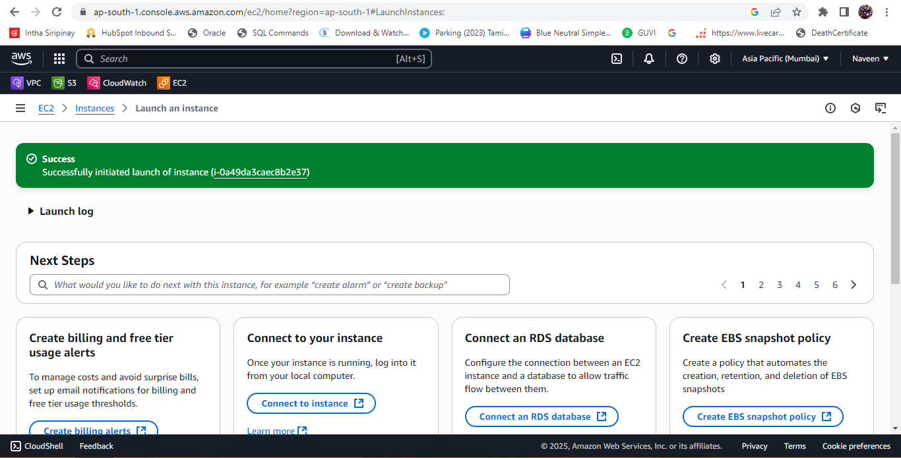

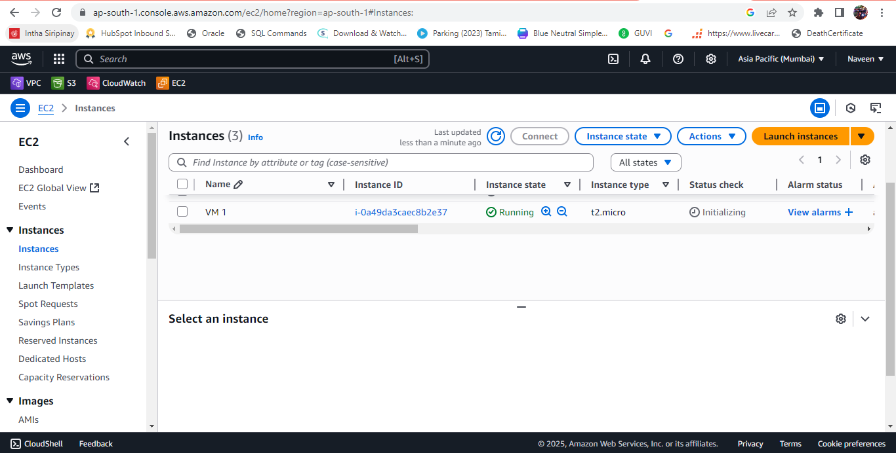

**STEP 2: -** Install Prometheus on EC2

Downloading the Prometheus using wget command

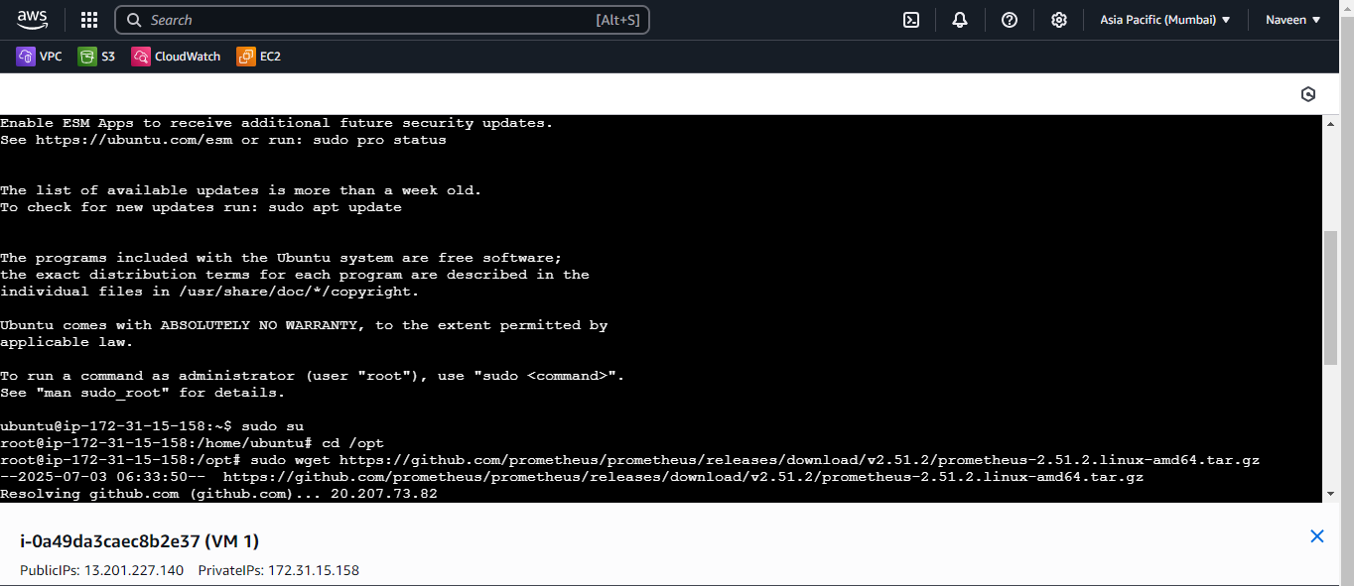

Untar the file using the below command

tar -xvf prometheus-2.51.2.linux-amd64.tar.gz

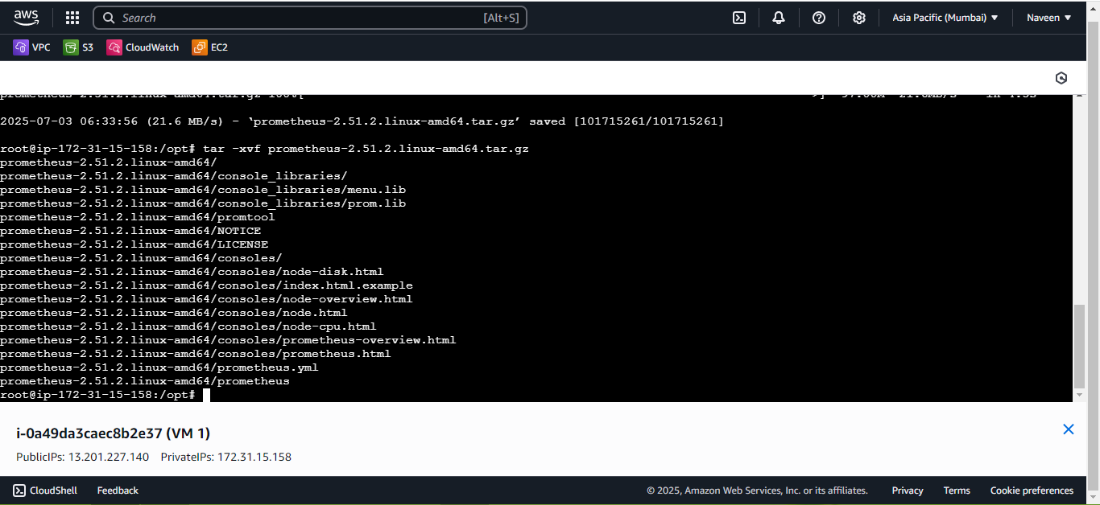

**Step 3: -** Configure Prometheus

Added minimal version of the config file

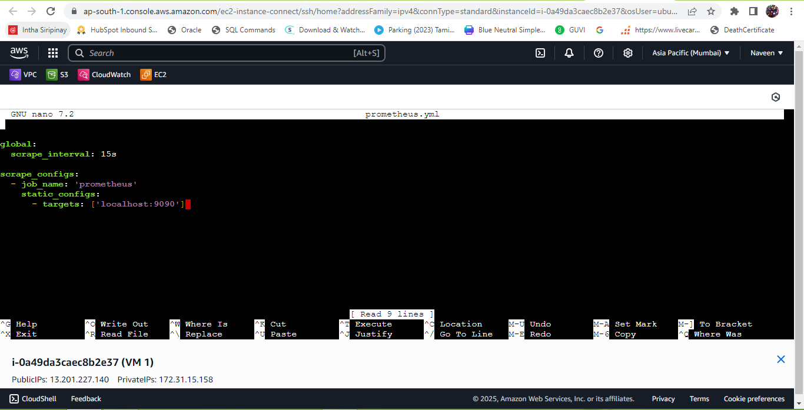

**Step 3: -** Staring Prometheus

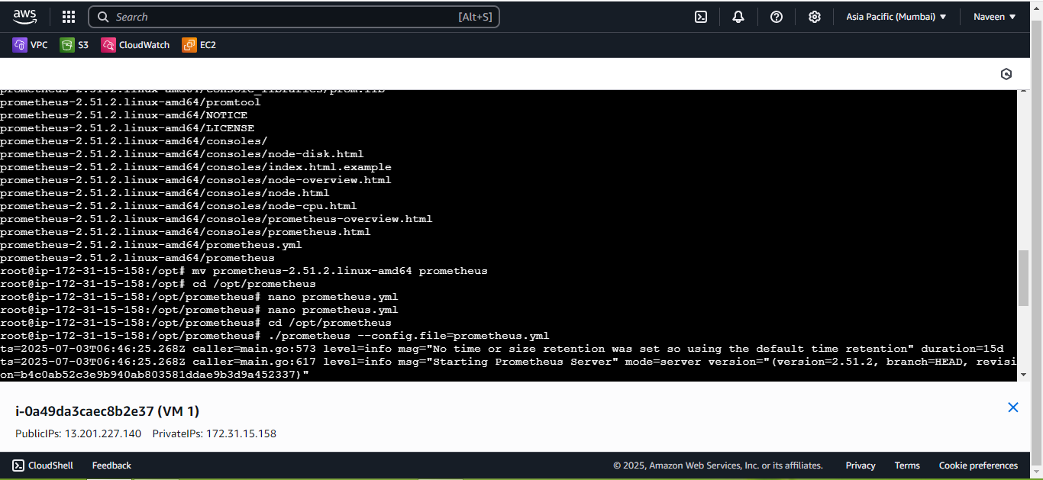

Checking in the browser

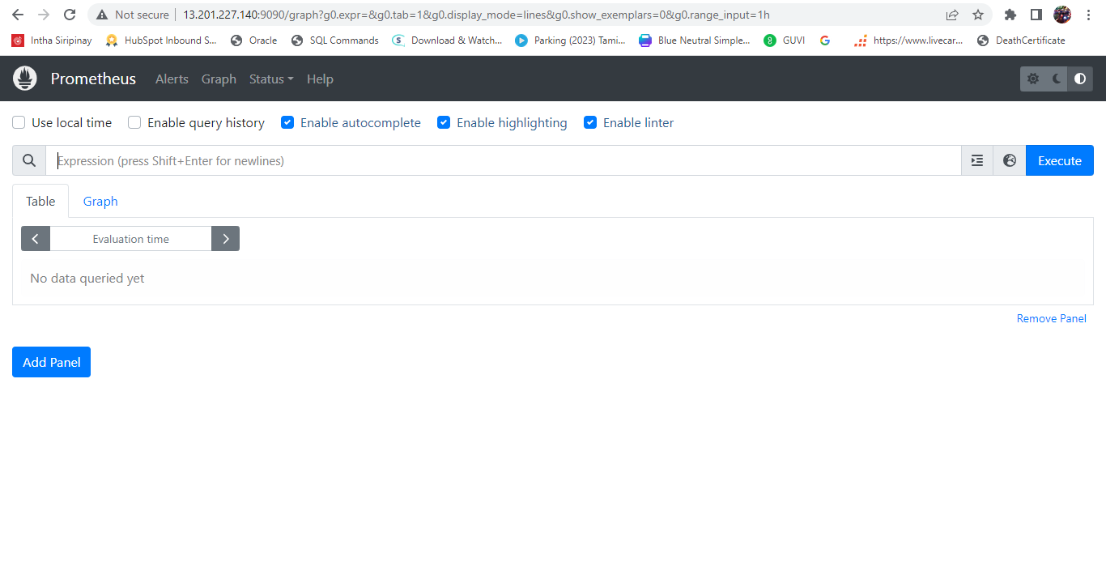

**Step 4: -** Install Grafana in the EC2 VM

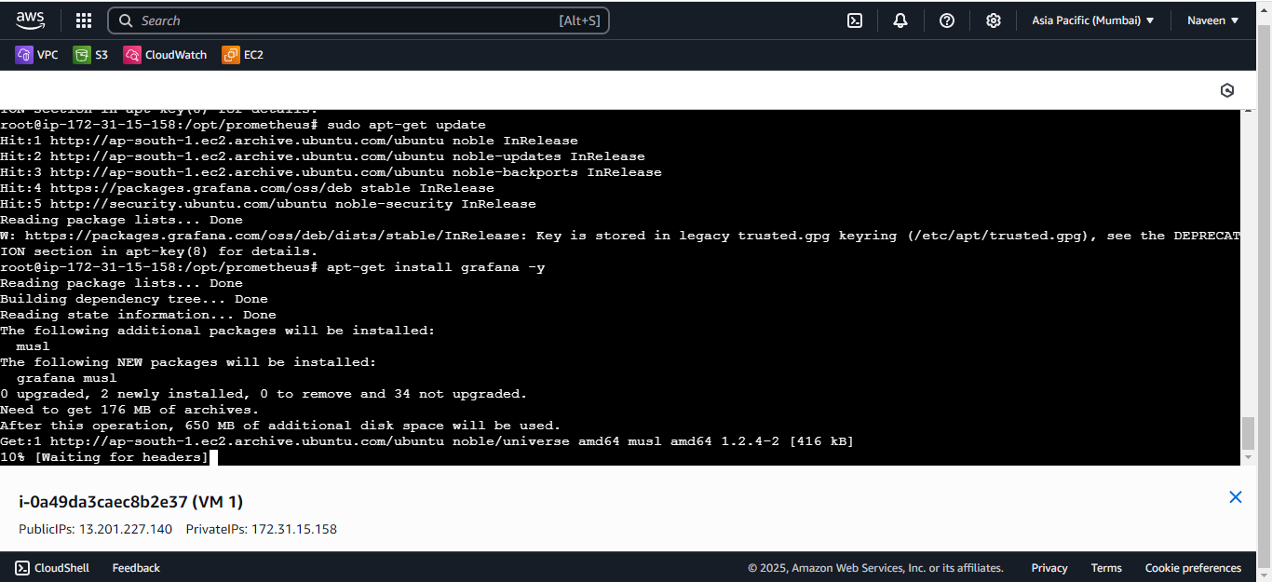

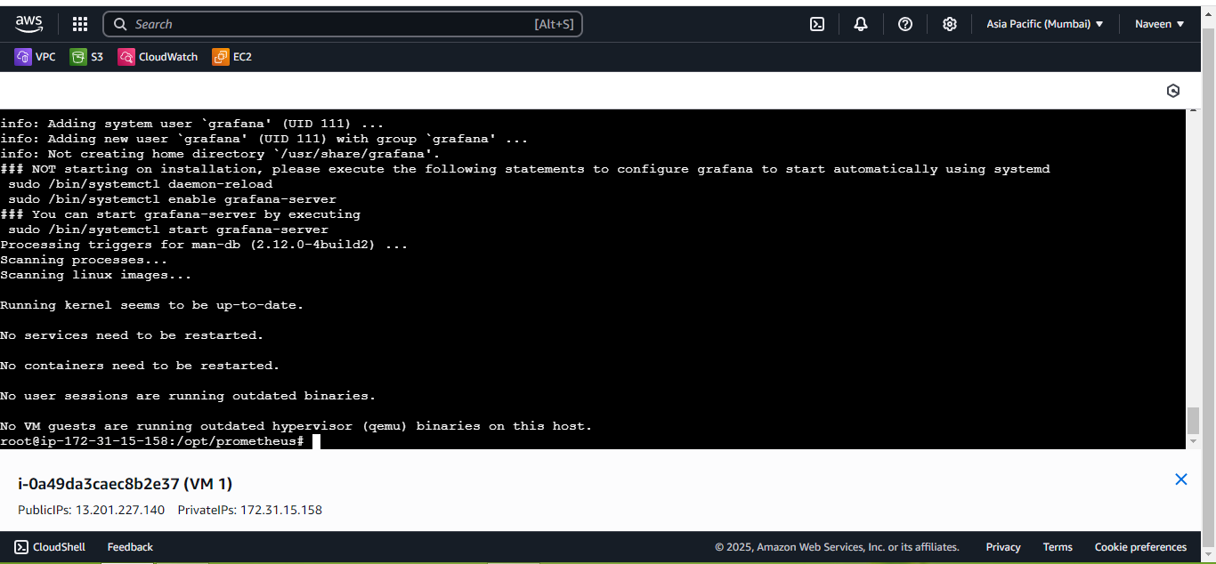

**Step 4: -** Start and Enable Grafana

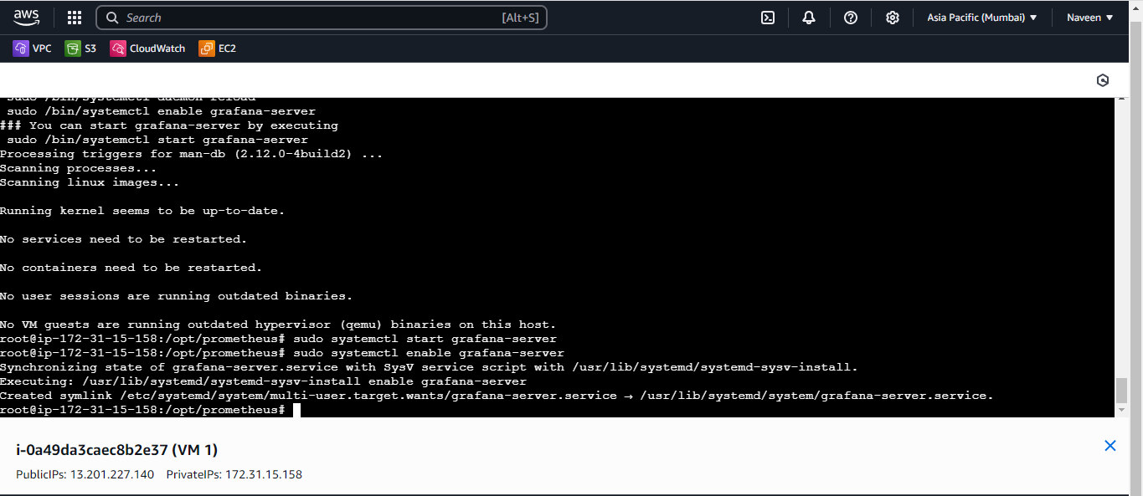

Checking in the browser

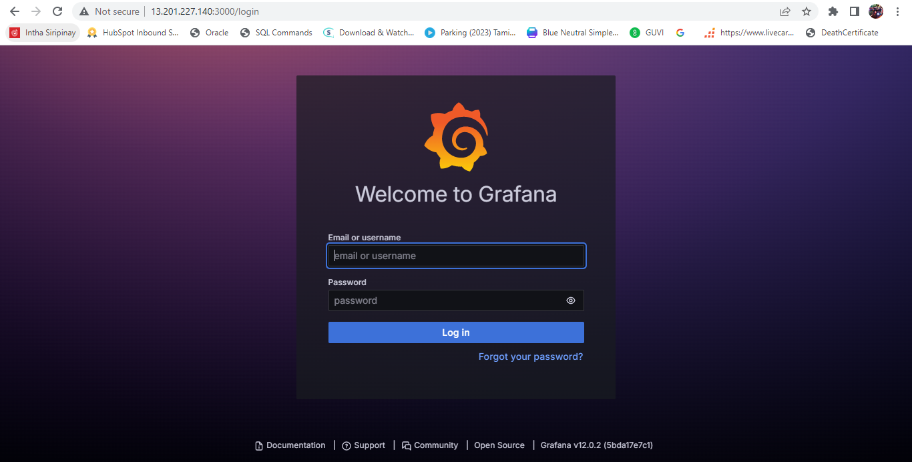

**Step 5: -** Connect Prometheus as a Data Source in Grafana

Logged in to Grafana using admin credentials

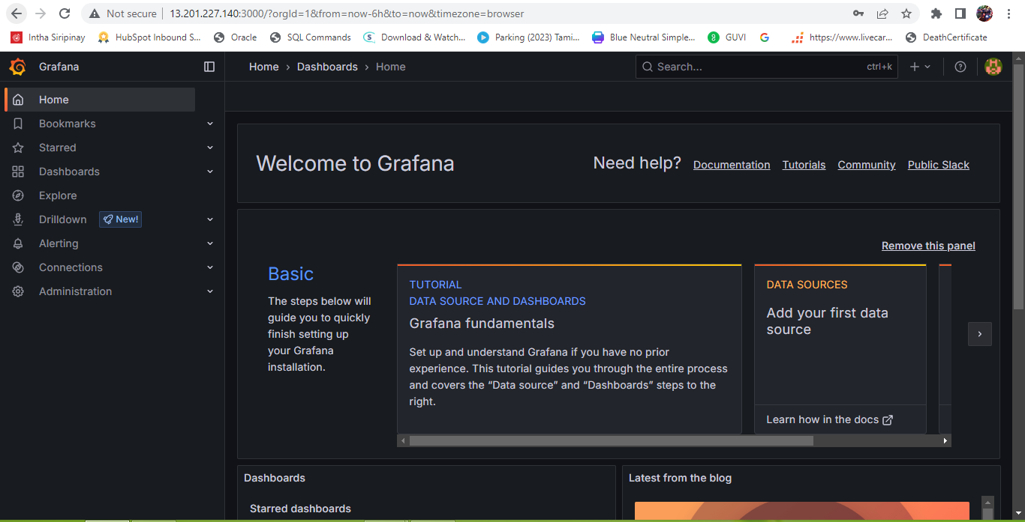

**STEP 6: -** Adding Prometheus as a Data Source in Grafana

Navigated to data source and adding the data source as Prometheus

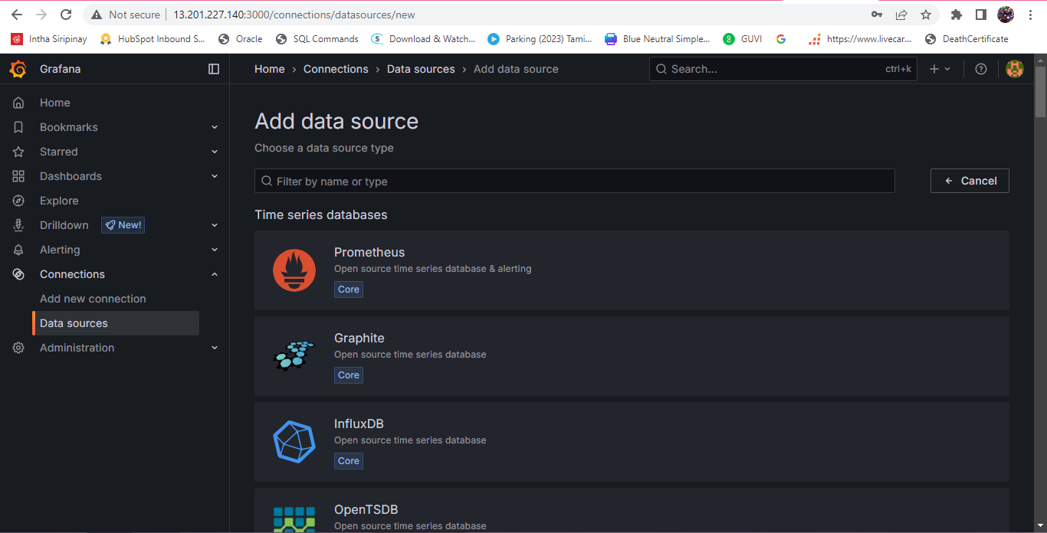

Specifying the local lost

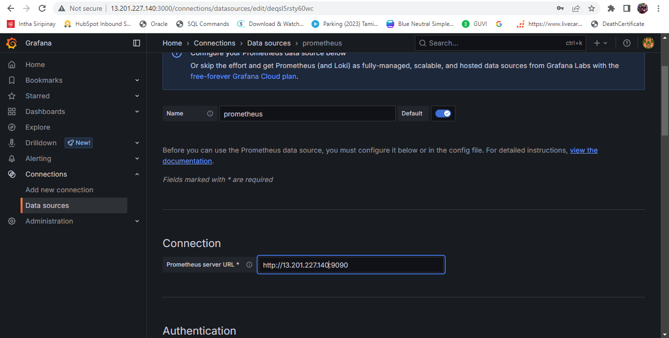

Testing the connection

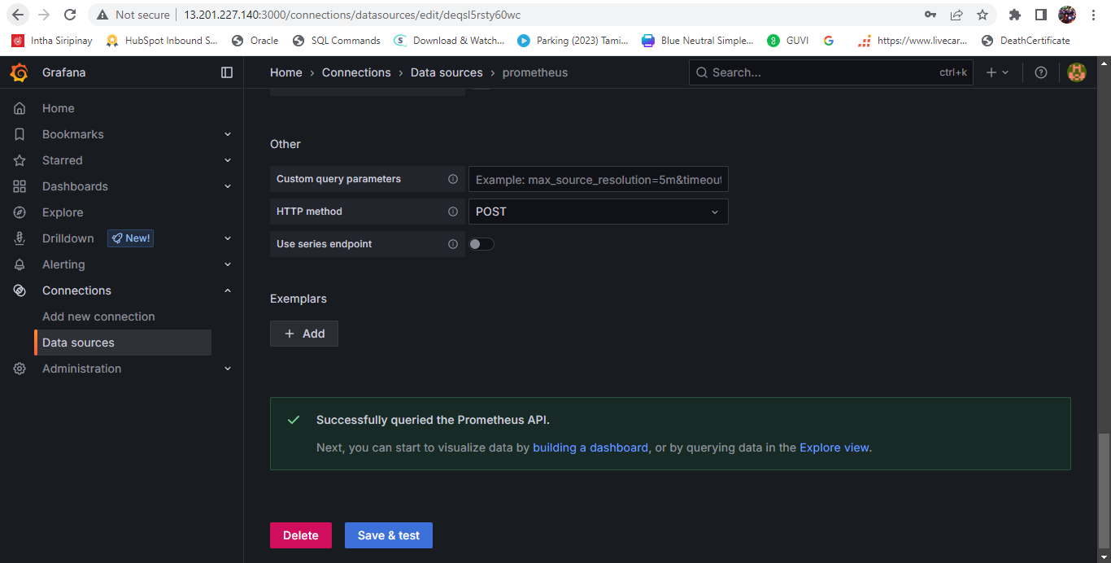

**Step 7: -** Create a Grafana Dashboard

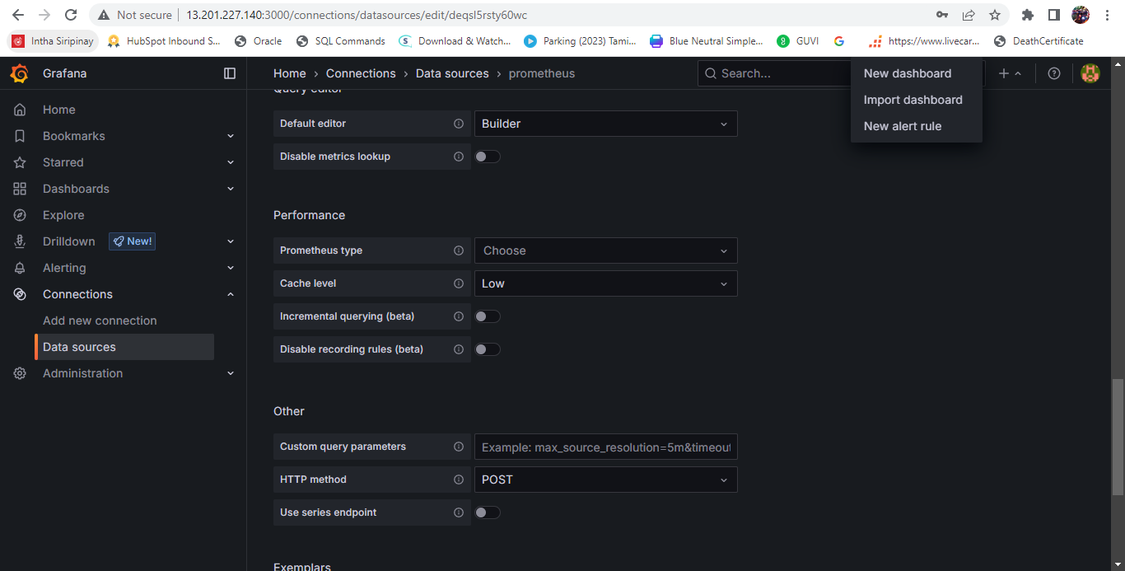

Adding a Prometheus Query

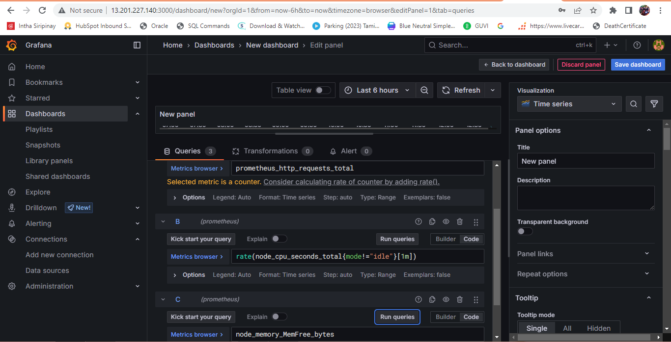

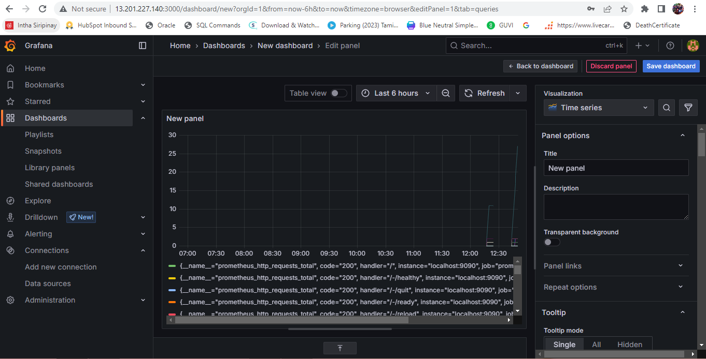

**Step 7: -** Customizing the Panel

Selected Bar chat

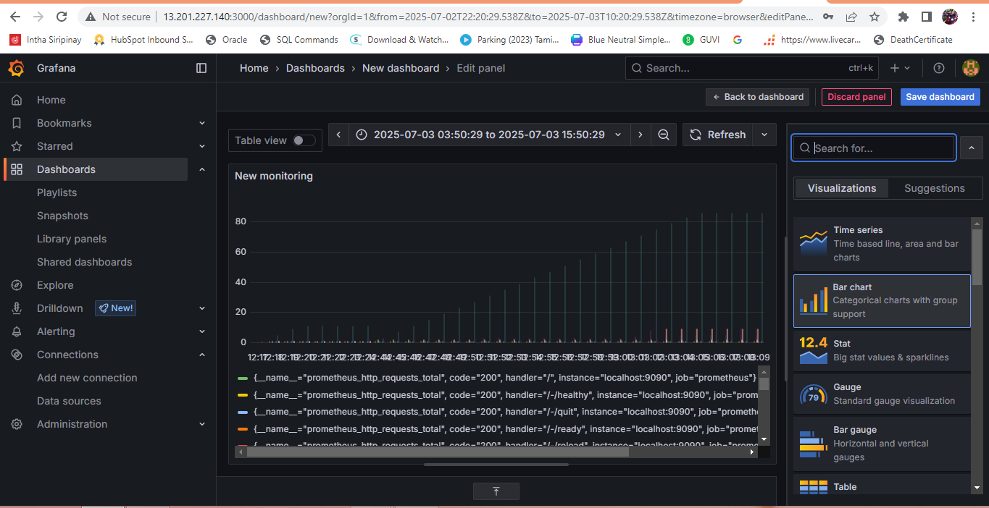

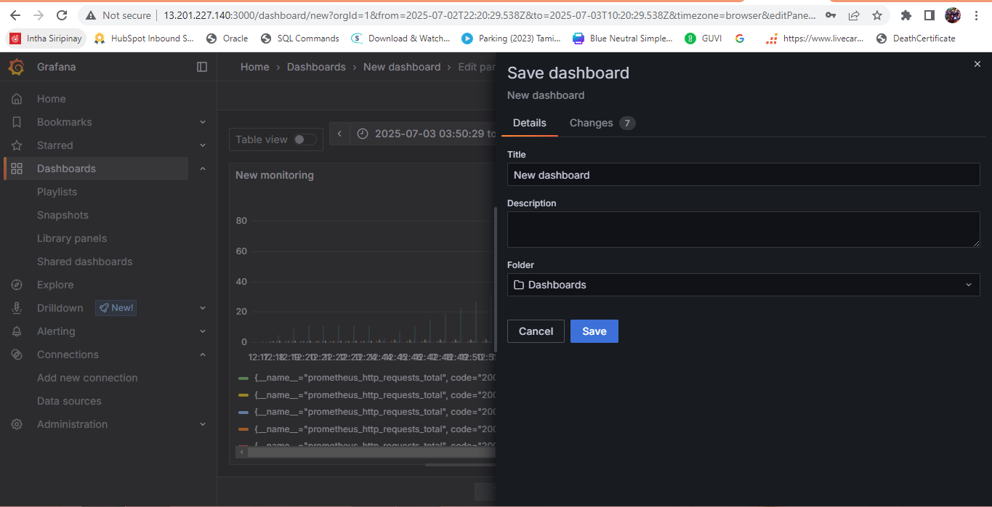

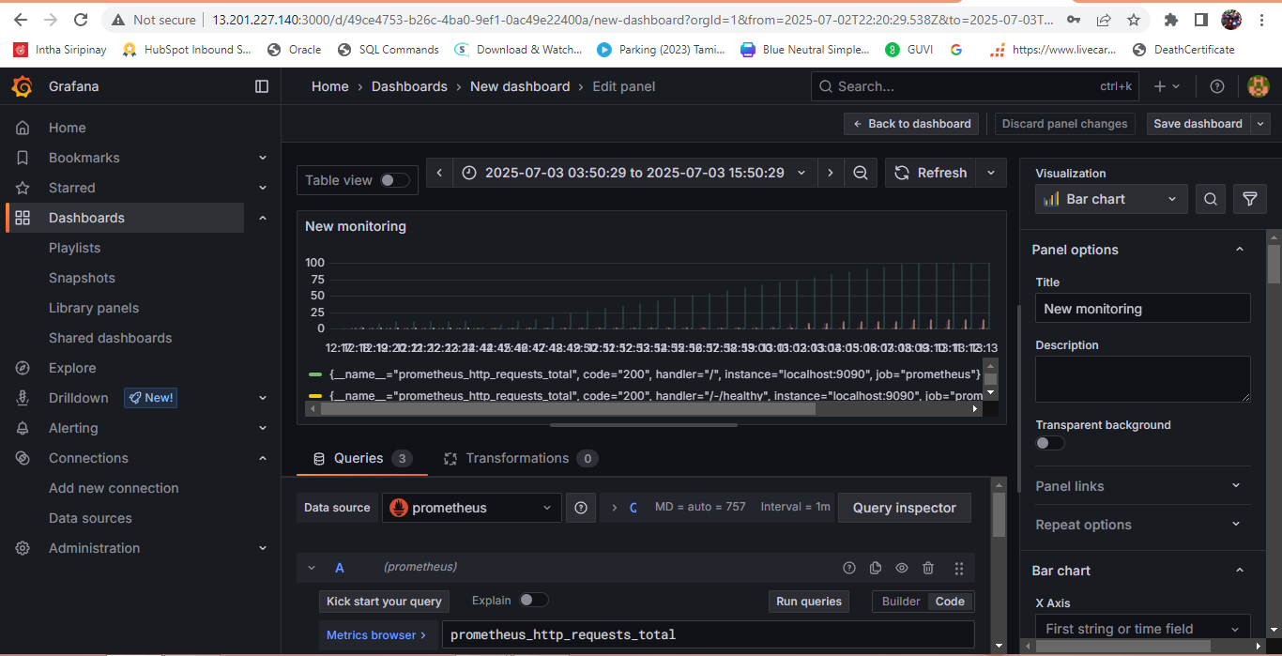

Dashboard is created in the Grafana using Prometheus metrics and viewed the metrics